Raptor  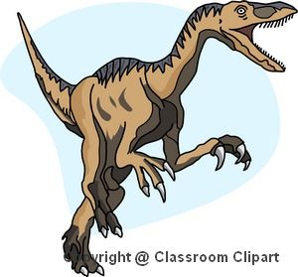 | Giganotosaurus  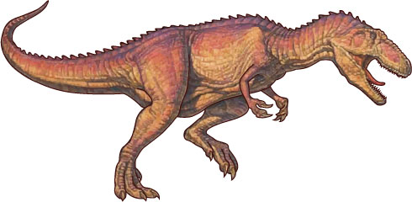 | Stygi  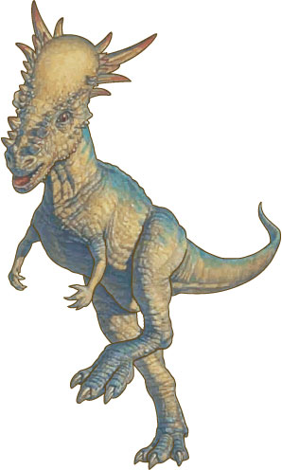
Strength: a²  Speed: a( b – c )  Size: 4a + d  Intelligence: cd | Strength: 4( a + 1 )  Speed: ( b + c )²  Size: 5 ( d – a )  Intelligence: ( a + 1 )3 | Strength: ( -b )²  Speed: 3a + d  Size: ( c – 1 )(a – 2)  Intelligence: 2d + c
Theriz  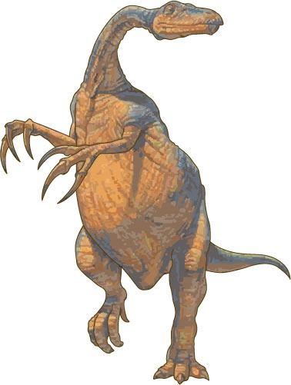 | Caudipteryx  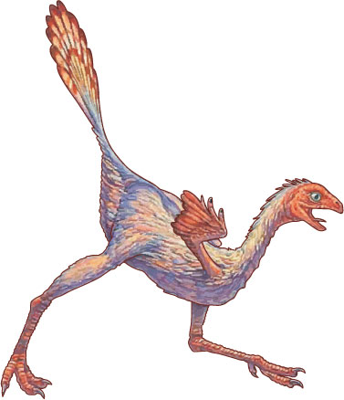 | Coelophysis  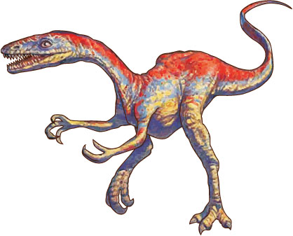
Strength: c²  Speed: cd  Size: ( a + 1 )( b – 1 )  Intelligence: 4d - 1 | Strength: ( -d – 1 )²  Speed: ( a – 3 )³  Size: 5c - b  Intelligence: 3( b + 1 ) | Strength: ( 6 – 2 )b  Speed: ( 3 + 1 )c  Size: ad  Intelligence: ( 2d – 3 )²
Archaeopteryx  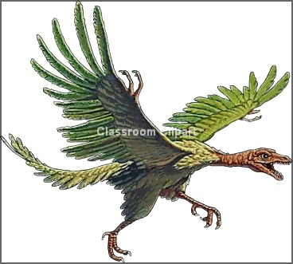 | Ankylosaurus  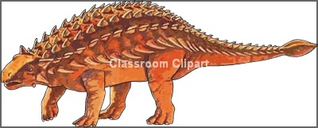 | Deinonychus  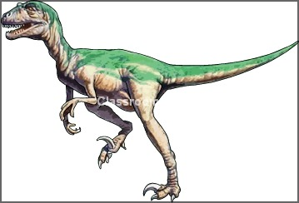
Strength: b + d + a + c  Speed: 3b  Size: 4( d – 1)  Intelligence: ( a + 1 )² | Strength: 2( b + c )  Speed: 4( a + 2 )  Size: ( 6 – 2 )²( a – b )  Intelligence: 3d | Strength: a( b + 1 )  Speed: 4c  Size: 2( a – 2 )²  Intelligence: d + 11

Amargasaurus  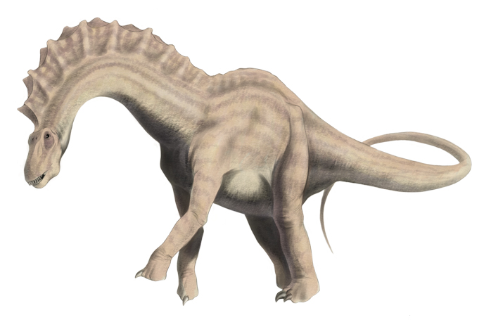 | Spinosaurus  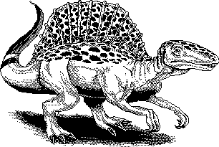 | Braciosaurus  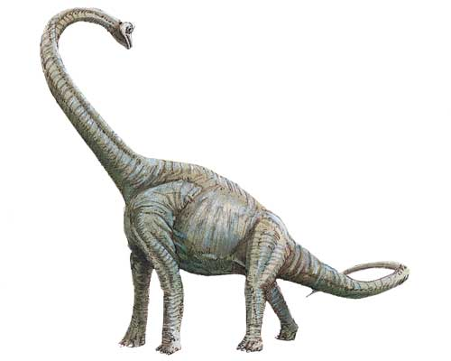
Strength: c²  Speed: c( d – a )  Size: 4b + c  Intelligence: ab | Strength: 4( b + 1 )  Speed: ( a + d )²  Size: 5 ( c – b )  Intelligence: ( d + 1 )3 | Strength: ( -d )²  Speed: 3b + c  Size: ( d – 1 )(b – 2)  Intelligence: 2a + c
Beipiaosaurus  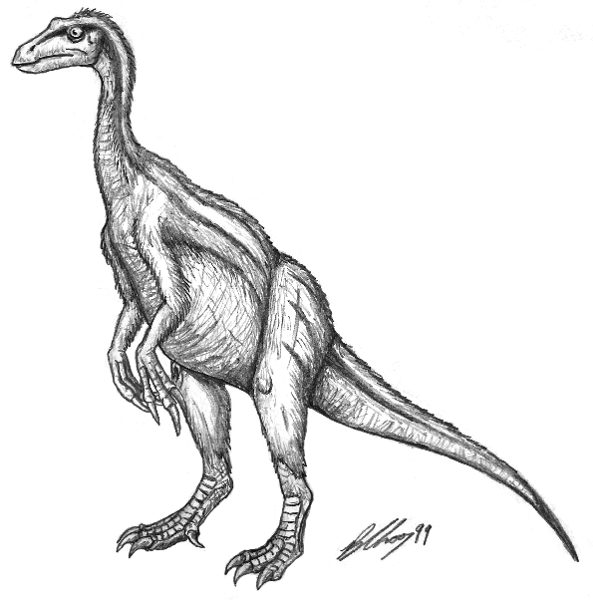 | Dromaeosaurus  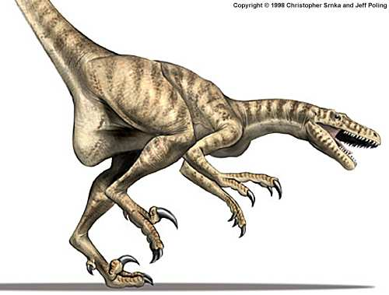 | Triceratops  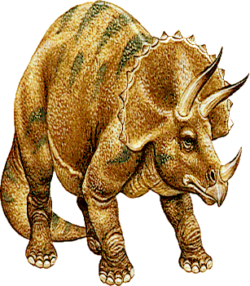
Strength: b²  Speed: ad  Size: ( d + 1 )( d – 1 )  Intelligence: 4c - 1 | Strength: ( -b – 1 )²  Speed: ( c – 3 )³  Size: 5a - b  Intelligence: 3( a + 1 ) | Strength: ( 7 – 2 )a  Speed: ( 2 + 1 )d  Size: bd  Intelligence: ( 2c – 3 )²
Gorgosaurus  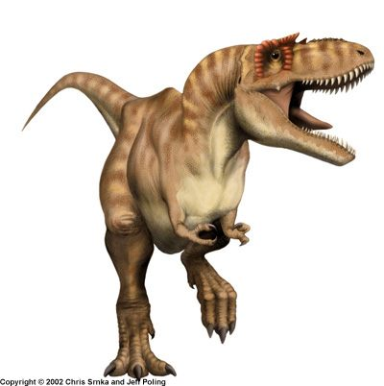 | Iguanadon  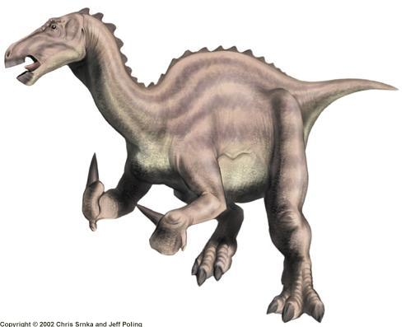 | Protoceratops  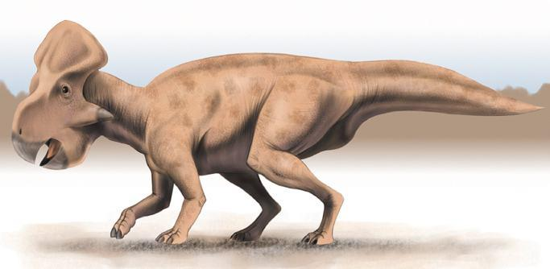
Strength: 3b + d  Speed: 3c  Size: 4( a – 1)  Intelligence: ( c + 1 )² | Strength: 2( d + a )  Speed: 4( c + 2 )  Size: ( 6 – 2 )²( b – a )  Intelligence: 3b | Strength: b( c + 1 )  Speed: 4d  Size: 2( c – 2 )²  Intelligence: a + 11

Parasaurolophus  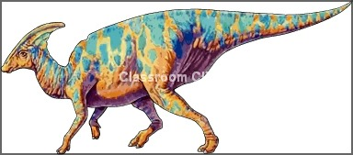 | Protarchaeopteryx  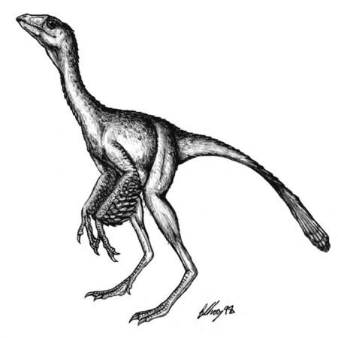 | Struthiomimus  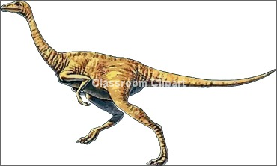
Strength: b²  Speed: d( a – c )  Size: 4c + b  Intelligence: cb | Strength: 4( d + 1 )  Speed: ( a + c )²  Size: 5 ( a – c )  Intelligence: ( b + 1 )3 | Strength: ( -a )²  Speed: 3c + d  Size: ( d – 1 )(a – 2)  Intelligence: 2c + b
Velociraptor  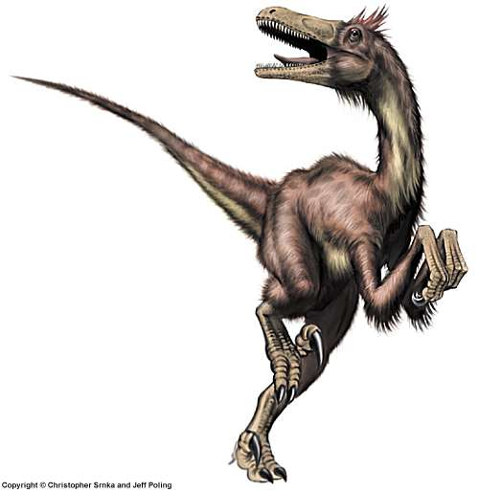 | Stegosaurus  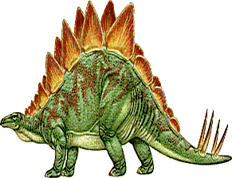 | Eolambia  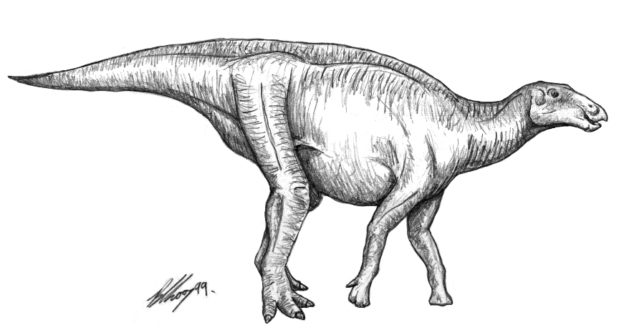
Strength: da  Speed: d²  Size: ( c + 1 )( c – 1 )  Intelligence: 4b - 1 | Strength: ( -a – 1 )²  Speed: ( c – 3 )³  Size: 5b - a  Intelligence: 3( d + 1 ) | Strength: ( 5 – 2 )a  Speed: ( 2 + 1 )b  Size: dc  Intelligence: ( 2b – 3 )²
Diplodocus  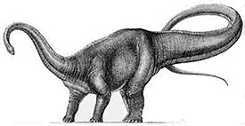 | Apatosaurus  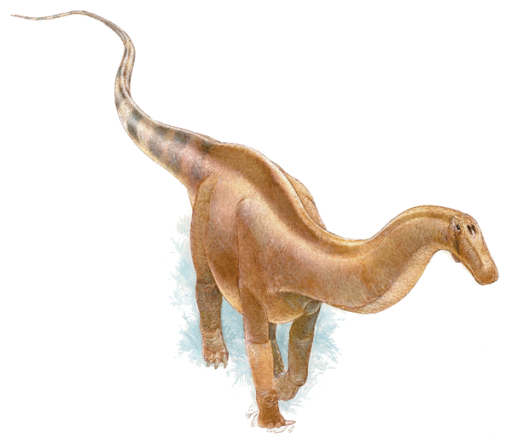 | Camasaurus  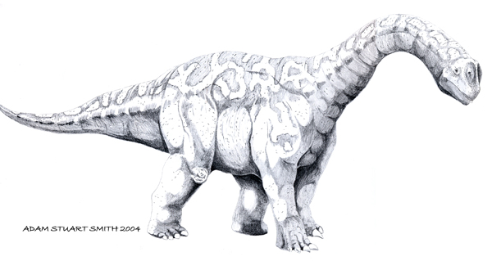
Strength: 3a + c  Speed: 3a  Size: 4( 8 – a )  Intelligence: ( 6 - b )² | Strength: 2( 9 - c )  Speed: 4( 7 - b )  Size: ( 8 – a )²( a – b )  Intelligence: 3( d + 1 ) | Strength: a( 7 - c )  Speed: 4( 8 – a )  Size: 2( 5 - b )²  Intelligence: 36 – 10a

a = 4  b = 3  c = 1  d = 2 | a = 2  b = -1  c = 4  d = 5 | a = -3  b = 2  c = 4  d = 1
a = -2  b = 2  c = 3  d = 1 | a = 0  b = 7  c = -1  d = 1 | a = -3  b = 3  c = 2  d = -2
a = 5  b = -3  c = 1  d = 2 | a = -1  b = 3  c = -2  d = 2 | a = 2  b = 0  c = -2  d = 1

